Exercise 5: Return Data from a Stored Procedure
QUERY:
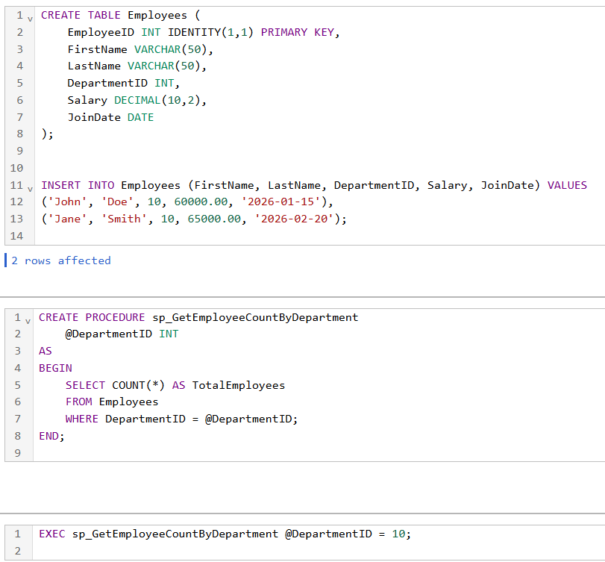
OUTPUT:
